**Engagement - November 2017 to January 2018**

The purpose of this document is to advise the Information to Members & Communications sub-committee, and the TPS Pension Board (TPSPB) of recent key activity on engagement with scheme members and employers, so as to assist the Board in its assurance role - in particular in the area of communicating information to members. Annex 1 gives a full briefing on the purpose of this report.

|  |  |
| --- | --- |
| **General communications** |  |

### The Teachers’ Pensions Scheme website refresh continues with updated content rolled out across 2018 in line with the timetable set out below. Monthly updates are provided to the Department through the Service Delivery Board and contract management Service Delivery Group.

### The removal of the need for members to input their TP Ref/DfE number when registering for an MPO account was implemented, members were notified via an accompanying campaign.

|  |  |  |  |  |  |  |  |  |  |  |  |  |  |  |  |
| --- | --- | --- | --- | --- | --- | --- | --- | --- | --- | --- | --- | --- | --- | --- | --- |
|  | **Jan** | **Feb** | **Mar** | **Apr** | **May** | **Jun** | **Jul** | **Aug** | **Sep** | **Oct** | **Nov** | **Dec** | **Jan** | **Feb** | **Mar** |
| Plan |  |  |  |  |  |  |  |  |  |  |  |  |  |  |  |
| Agree Scope |  |  |  |  |  |  |  |  |  |  |  |  |  |  |  |
| Research & Focus Groups |  |  |  |  |  |  |  |  |  |  |  |  |  |  |  |
| Design of Secure Areas in Scope |  |  |  |  |  |  |  |  |  |  |  |  |  |  |  |
| Testing |  |  |  |  |  |  |  |  |  |  |  |  |  |  |  |
| Development |  |  |  |  |  |  |  |  |  |  |  |  |  |  |  |
| Secure Content |  |  |  |  |  |  |  |  |  |  |  |  |  |  |  |
| Sweeps |  |  |  |  |  |  |  |  |  |  |  |  |  |  |  |

### **Teachers’ Pensions Customer Contact Model**

1. This subcommittee is aware of, and has been involved in, considering the challenges faced to meet the demand from members for contact with the administrator.
2. Since the discussions at QSB, TP have deployed further resource from outside TP to support the contact centre to take calls during December and January until the recruitment of the extra staff is complete. This extra resource has enabled answering 93% of the 42,213 calls offered in January with average wait times below 3.5 minutes.
3. The prioritised bereavement and ill health calls were answered in the required standard of 85% in 30 seconds. Performance in December was similarly very good, but was based on a lower call level (as expected within the seasonal profile). The profile of resources and performance has been the equivalent during January of answering 9,000 calls per week and this increased resource will be in place for up to a year, until the Digital Contact Centre becomes fully effective. During this time period we expect IT changes to be embedded that will support this change – these are:

* an improved password reset process (already implemented)
* a new two-tier log on process (Q2)
* Online opt out processes (Q2)
* Revised MPO dashboard and revised registration journey for new MPO accounts

1. The support from other areas of the business will remain in place whilst TP continue with the recruitment and training programme to increase resource in the contact centre team.
2. Customer satisfaction results and associated commentary indicated a review of the call flow and call routing programming was necessary. DfE challenged TP to analyse these details, streamline the process and reduce the number of telephony options required prior to connecting to an adviser. New programming has been introduced which reduces the initial option selection from seven to three, with a secondary layer of options prior to connecting to an adviser.
3. Meetings have been held with the Engagement team to discuss and commence the implementation process of a webchat facility for members and are likely to continue over the next few months.
4. DfE are monitoring contact centre performance through the SDB and service delivery group, with a challenge to TP that forecasting of contact centre traffic is in place and reported on and any potential risk can be identified and mitigated. To demonstrate this level of challenge, TP are providing increased reporting for calls into the contact centre via the service delivery report.
5. The top 4 reasons for contact in this quarter are:
6. Tax & payroll
7. Planning for retirement
8. Website (pin/password reset & struggling to find info (pensioner members))
9. Death
10. The table below shows the number of calls received per category in the period.

|  |  |  |  |  |
| --- | --- | --- | --- | --- |
| **Month** | **Tax & Payroll** | **Planning for Retirement** | **Website** | **Death** |
| November | 5,965 | 4,426 | 8,230 | 7,976 |
| December | 3,866 | 2,795 | 1,683 | 1,875 |
| January | 5,965 | 4,426 | 2,701 | 2,849 |
| Total | 15,974 | 12,888 | 8,230 | 7,976 |

1. To further enhance member experience, a group of representatives from the Contact Centre have been working closely with the Engagement team to give their insight on the website and suggested improvements are implemented to reduce calls to the business.
2. During this period, DfE, via the QSB, has continued to challenge Capita to consider what steps can be taken to improve member experience whilst the improvements in telephony capacity and digital engagement take effect. DfE are monitoring TP progress towards resolving this issue via the service delivery groups and monthly Service Delivery Board meeting, issue TP.I.034 refers.

### **Stakeholder engagement**

### In the period, there were twelve seminars for TPS members, with 205 people registering. The webinar programme delivered eighteen webinars with 176 people registering for the events.

1. The Teachers’ Pensions Action Forum (TPAF) event took place in London in November, with representatives from all stakeholder groups. The workshops covered Monthly Data Collection (MDC) and Employer Review (MDC2), incorporating My Pension Online (MPO). Positive feedback was received from event attendees.

### Acting on feedback from TPSPB, DfE have continued to challenge TP to generate members’ engagement opportunities via My Pension Online (MPO). There are now 670k members with an MPO account, an increase of 48k in the period. This success is attributed to the launch of the Employer MPO report which has generated 13k registrations since its launch in July 2017.

1. TP were challenged by TPARG to broaden the scope of engagements with employers covered by outcome measures, to maximise opportunities to obtain feedback. A pilot to capture employer feedback via the website commenced in January 2018.

|  |  |
| --- | --- |
| **Member engagement and campaigns** |  |

1. Engagement contract Outcomes 2 & 3 for contract year 7 (1 October 2017 to 30 September 2018):

|  |  |  |  |
| --- | --- | --- | --- |
| **Outcome** | **Description** | **Target** | **YTD performance** |
| 2 | Members understand the value of their Teachers’ Pension | 92% | 97.30% |
| 3 | Members are actively planning for their retirement | 86% | 85.78% |

### Year to date performance for Outcomes 2 & 3 for contract year 7 is on target; positive feedback received from both employers and members demonstrates high levels of interactivity and engagement with TP and the TPS service.

### The Newly Qualified Teachers (NQT) project continued throughout November, December & January, with automated communications to all NQTs who have signed up via ‘PensionPlanIt’.

### DfE are content that these campaigns/projects deliver value for money and are generating the right results, particularly with the increase in MPO accounts being evident.

|  |  |
| --- | --- |
| **Employer engagement and campaigns** |  |

1. The MPO registration campaign advised employers of the changes to the improvements to registration to MPO. An additional campaign was to advise employers of the changes to the contribution salary bands from April 2018 (this had previously been scheduled for March).
2. Engagement contract Outcome 11: Contract year 7: 1 October 2017 to 30 September 2018

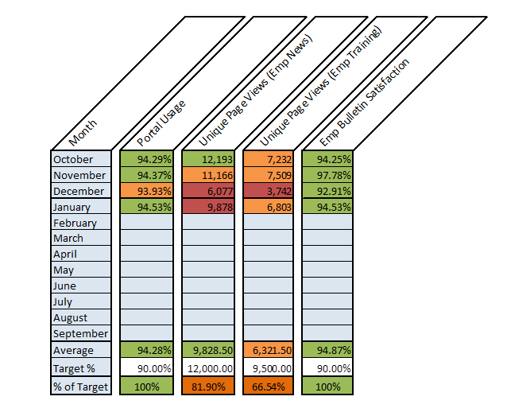

### Viewing of the Employer training material is currently performing below its year-end target. However, it is anticipated that this sub-target will be achieved by the end of the current contract year, with the current underperformance being part of the natural peaks & troughs that can occur over the course of a scheme year.

1. MDC communications continue to be delivered in line with the established engagement plan. As we approach the deadline of April 2018, TP is ramping up use of the escalation process that is in place to support employers yet to join the on boarding phase of MDC. A total of 694 individual letters were issued to establishments on 16 February 2018. The majority of these employers fell within the academies and independent school sectors. Teachers’ Pensions are currently managing responses and ensuring employers on board prior to the April 2018 deadline.
2. Early indications suggest that employers wrongly assumed that their Payroll providers would automatically on board them to MDC. Teachers’ Pensions will repeat the escalation process as necessary during March 2018.

### The revised process for engaging with academies is continuing, with all new establishments being contacted directly by telephone in the first instance, and then following that up by email. The number of open academies at the end of January is 7,060. All new academies are advised they can only submit service and salary information via MDC.

### 

**MPO report to employers**

1. As reported above, there are now 670k members with an MPO account, with the launch of the Employer MPO report having played a significant part in generating further registrations. In reporting period, the report has led to 6,285 member registrations (broken down as November 2,860; December 1,212 & January 2,213).
2. The table below details member volumes and MPO make-up based on the establishments from the report going live:

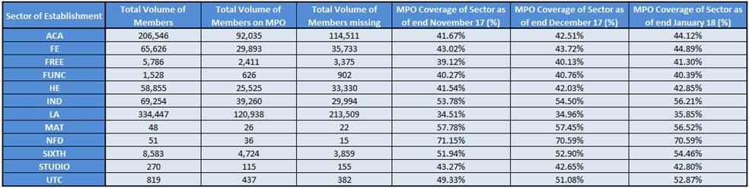

1. DfE are encouraged by the increase in MPO accounts, and are monitoring this through the service delivery group meetings.

|  |  |
| --- | --- |
| **Website and social media** |  |

### Web sessions 1 November 2017 to 31 January 2018:

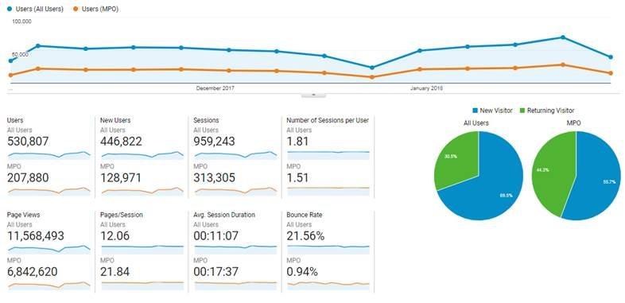

1. Social media has continued to prove positive in terms of Followers, Likes, and impressions. TP have seen enquiries coming through social media in terms of members choosing social media to engage with them rather than calling the Contact Centre.

### The scheme has 3,930 Twitter followers (126 additions in the reporting period), 6,894 Facebook ‘friends’, and LinkedIn followers have increased to 499 with 5,509 impressions. There has been an increase in social media engagement as members contact TP through Facebook and Twitter with their queries.

### YouTube has now generated 174,356 views to date and achieved 145 subscribers.

|  |  |
| --- | --- |
| **Forward look** |  |

### Streamlined way for members to reset their MPO password/pin.

### Issuing Employer Bulletin, Payroll Provider and Member bulletins.

### Continuation of the MDC engagement plan.

* Employer portal research
* MPO refresh
* Social media advertising campaigns and planned posts
* Webchat trial
* Focus group preparation
* MDC 2 discussions
* MAT’s models discussions
* Scheme Valuation comms
* GDPR comms
* Opting out online only
* Member conversion campaign
* Member faster accrual campaign which will go to all members who have previously taken up the flexibility, to remind them of the 31 March deadline for renewal.
* Campaign to employers regarding EOYC process and to advise employers of the deadlines and steps they need to take and signpost them to website resources.

1. DfE’s view is that TP are progressing well with delivering the communications strategy. There are some improvements in the contact centre area, with increased telephony capacity and IT improvements to allow members to easily self-serve are planned. The challenge to the administration is to encourage use of online channels as they are easy to use, ensuring members engage better with their pension long-term. DfE are confident that the right IT changes have been prioritised and the correct monitoring of contact is in place to assess whether the shift to online is working. Digital Focus is one of the strategic objectives of the contract and achievement of the shift to digital (whilst making clear allowance for vulnerable customers) is monitored closely through various fora including the Quarterly Service Board.
2. Ultimately, steps are being taken to address and resolve the issues involved and to implement a multi-channel customer contact model, which will provide sufficient capacity and flexibility to manage and handle volumes going forward.

Acronyms used within this report:

|  |  |  |  |
| --- | --- | --- | --- |
| QSB | Quarterly Strategy Board | TPS | Teachers’ Pension Scheme |
| MDC | Monthly Data Collection | NQT | Newly Qualified Teacher |
| MPO | My Pension Online | TPAF | Teachers Pensions Administration Forum |
| KPI | Key Performance Indicator(s) | TPARG | Teachers’ Pensions Administration Review Group |
| CC | Contact Centre | SDB | Service Delivery Board |

**Annex 1**

###### The purpose of this document is to advise the Information to Members & Communications sub-committee, and the TPS Pension Board (TPSPB) of recent key activity on engagement with scheme members and employers, so as to assist the Board in its assurance role - in particular in the area of communicating information to members. The report also aims to assist the Board in its strategic role by providing information on specific actions and projects that aim to ensure the administration continues to improve and best serve all stakeholders’ needs.

**Background**

#### The overarching objective for scheme engagement within the current contract is to keep members and employers informed of scheme activity that affects them through a planned series of communications - understanding, developing and utilising the most effective channels and techniques.

#### From an employer perspective, this means ensuring that they are aware of and are delivering their obligations as responsible employers through:

#### Improving employers’ understanding of their responsibilities and providing appropriate support for them to deliver these effectively

#### Improving the recognition and appreciation by employers of the value of the scheme to its employees

#### Improving the engagement and support that employers provide to members on pension retirement planning

#### To provide scheme members with a more dynamic, effective and accessible insight into their pension and its benefits, we aim to:

#### Increase members’ awareness of pensions in general to promote more effective pension planning

#### Ensure that the service proactively engages with members

#### Ensure members have ready access to information which allows them to understand and make best use of scheme provisions

#### Respond to customer feedback to ensure scheme communication continues to evolve, and to drive improvements in customer service.

#### Initially, guided by the Government’s ‘Digital by Default’ agenda, we have continued the drive towards electronic communications as a main channel for engagement. Through for example: the on-lining of P60 and Benefit Statements; the push to increase the number of members with a My Pensions Online (MPO) account; the implementation of Monthly Data Capture (MDC) from 2018 to streamline the provision of member data etc. These moves help deliver a more up-to-date service and to keep pace with IT developments, allowing us access to better scheme data and to constantly improve the member experience.

### The sub-committee’s role within this will be to seek assurance that these objectives continue to be met effectively and to provide assurance to the TPSPB that the engagement plan is appropriate and that mechanisms are in place to ensure the timely delivery of key messages to members.