**Engagement November 2015 – January 2016**

Quarterly update

TPS engagement for the current year has been agreed and approved by the contract management team. The main focus will be to undertake an in-depth review of the content and functionality of the TPS website. This will be fully informed by employer and employee user feedback.

We have agreed with Department colleagues that future Marketing Exemption exercises (to agree projects which actively promote the benefits of the scheme, and their associated costs) will be delivered in line with contract years (October-September) rather than in line with financial years, which has previously been the case. This will allow more efficient communications planning.

Building on the much improved processes to receive timely member data from employers through the Annual Service Return exercise, activity to proactively engage and support employers has been agreed with the Department. The communications will more clearly define the process and potential consequences for members (a lack of current service and salary data) and employers (ultimately, they will be reported to the Pensions Regulator) should they fail to provide accurate and timely data. The first phase of engagement will take place in March.

A bespoke section on taxation and the potential impact on scheme members of HMRC changes to Annual Allowance and Lifetime Allowance provision went live on the TPS website in December. Material includes briefing notes to help members and their financial advisors to understand these changes. Before publication the pages were subject to review and critical assessment by employer member representatives (via TPARG members) and they have proved popular with users.

High earning members (i.e. those most likely to be affected) have been subject to a campaign to draw their attention to the issues and to direct them to the published information.

The scheme has been approached by the Education Support Partnership (formerly the Teacher Support Network) to ask if literature promoting the benefits of the charity can be included in the distribution of scheme member P60s. This is currently under consideration, but is likely to be declined as the Department should not be perceived to endorse one charitable organisation in preference to other similarly worthwhile causes. In addition, it is not feasible to consider offering a promotional facility more widely as this would involve implementing a governance infrastructure to embed assurance and due diligence procedures for which the team is not resourced.

To enhance awareness of the transition of Annual Benefit Statements moving from hard mailing to online only, the scheme has agreed with the Department that TPS communications on this key topic will be included in the Departmental communications. This will include re-Tweeting links to scheme announcements and postings on Facebook, as well as the inclusion of scheme notices to employers through the Department’s termly schools email.

Scheme communications will also be shared with the Department’s campaign team, highlighting key themes which we would like to be included in future Department communications.

As a result of this closer engagement with the Department’s campaigns team, we will be provided with the opportunity to feed into a wider communications review that the Department is undertaking, which should provide options to promote scheme activity in future.

|  |  |
| --- | --- |
| **Member engagement and Campaigns** |  |

Although short of the annual target, website visitor numbers totalled 2.92m in 2015. In reality the notional target was based on the previous year which was boosted by an exceptionally high level of communications around scheme reform.

Following an anticipated drop in visitors during December as a result of the holiday period, numbers have recovered in January.

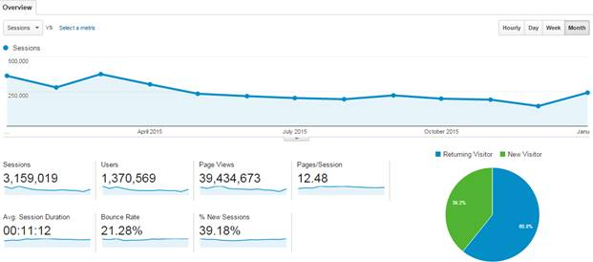

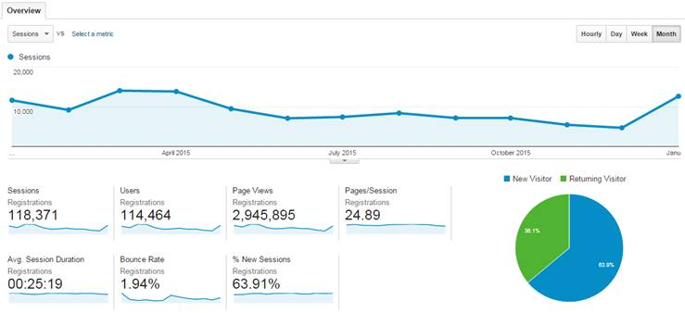

The scheme now has over 1,300 Twitter followers and 92 ‘likes’ on Facebook. The current volume and increase in numbers remain relatively low, but it is accepted that this will be accelerated by increased exposure through central Department communications and ‘word of mouth’ as communications are re-Tweeted. Twitter feeds are now including wider educational themes to retain interest with current followers and to broaden the appeal to a wider audience.

My Pension Online (MPO) account holder numbers continue to increase, with a total of 405k members now registered. This remains on target to reach its Outcome target in the current contract year.

Seasonal campaigns aimed at both new entrants and new retirees, and those looking to explore pension options over the holiday period proved successful, hitting their open rate targets.

In January, key campaigns including messaging on Annual Benefit Statements and to direct members to guidance on changes in tax allowances, were successfully delivered.

|  |  |
| --- | --- |
| **Employer engagement and Campaigns** |  |

To specifically address academy engagement issues, we have approached Department academies colleagues to have a specific TPS update included in their regular communications to academy employers. This proved a particularly effective route into academies when delivering scheme reform communications.

Employer campaigns focussing on providing support to new employers were delivered in November and January. The monthly employer bulletin also provides a series of updates, including information on contracting out, ABS, key developments and tax changes. In addition, a follow-up campaign to all employers encouraged them to promote the new scheme flexibilities - providing resources to share with their employees.

A campaign to encourage employer feedback on the TPS website was also delivered, the findings will feed into the forthcoming website content review.

Also in response to feedback from employer representatives, the re-employment certificate has been updated to make it easier to identify the period of service which the form relates to.

Feedback has been sought from employers participating in the early stages of the MDC on-boarding process. This will be used to inform the support and documentation provided in future phases of the project. Further details and an update of the MDC process are provided in the administration update.

|  |  |
| --- | --- |
| **Seminars/Webinars** |  |

12 employee seminars (338 registrations) and 11 webinars (74 registrations) were delivered in the last quarter. No webinars were delivered in January as the future of these events is currently under review due to reduced interest and take-up.

As part of that review TP is looking at the Employer Support function and the most appropriate methods of supporting employers with their enquiries and training to ensure they are receiving the most appropriate service. Webinars are a part of this review.

Videos are in development and the initial wave will prioritise subjects including starters and leavers, contributions, Annual Service Returns and retirement. Future topics will include material aimed at academies and new employers.

The website review will help to identify if further videos are required. We will also engage with stakeholders to gain a better understanding of their requirements.

|  |  |
| --- | --- |
| **Forward look** |  |

Work will commence on the review of the website content and functionality to improve the member experience. A content plan will be developed to support this activity.

Targeted member campaigns relating to scheme flexibilities and re-employment will be delivered in the next quarter, along with continuing communications to members and employers regarding the on-lining of Annual Benefit Statements.

A programme of automated communications aimed at ‘dormant’ member accounts will be initiated and continue across the year and the first stages of the Annual Service Return engagement process will be implemented in February.

April will see the relaunch on this year’s TPS toolkit campaign – which has proved extremely popular with employers in the past. The toolkit provides a series of member resources.