TPSPB report – August to October 2018

The purpose of this document is to advise the sub-committees and the TPS Pension Board (TPSPB) of recent key activities relating to the administration of the scheme to assist with its assurance role. The report also aims to assist the Board in its strategic role by providing information on specific actions and projects that aim to ensure the administration continues to improve and best serve all stakeholders’ needs.

The TPS contract year commences from 1October so the performance reported in this quarter spans both contract year 7 (1 October 2017 to 30th September 2018) and Contract Year 8; this will be highlighted in the report narratives.

Service update

- Teachers’ Pensions (TP) successfully achieved the 6 October deadline for the Annual Allowance (AA) exercise to issue Pension Saving Statements.

- Excellent results were achieved with respect to the Summer Retirement Exercise, with all members paid as of 1 September 2018. The total volume of retirements processed was 11,412.

Bereavement

- TP is clearing business as usual (BAU) cases in line with SLA expectations. There are 1,224 outstanding cases across the SLA; 650 of those are cases where we require further information, which has been asked for, the remainder have been reviewed through the triage arrangements in place and are being dealt within on a priority order basis. TP.1.038 issue refers.

- August, saw a further 4% increase in death notifications and based on historical trends this is likely to continue through the winter months meaning activity here is likely to remain higher than expected.

- Overall SLA performance is generally good, with 4a Death/Ill Health – initial contact/assessment of benefit - achieving an average of 99.89% over the quarter. There are 6 outstanding cases, which are all awaiting further information from a 3rd party (e.g. employer, spouse, and probate).

- SLA4b Death/Ill Health benefit payments (continuing entitlement) has achieved an average of 82.88% over the quarter. There are 278 outstanding cases, of which 104 are awaiting further information from a 3rd party. TP is maintaining the BAU cases, but as aged cases are closed, these are impacting on SLA performance.

- SLA4c: Death/Ill Health benefit payments (no continuing entitlement) has achieved an average of 92.98% over the quarter. There are 940 outstanding cases, of which, 540 cases are, awaiting further information from a 3rd party.

Other impacts of increase in members

- TP is continuing to work through outstanding revisions cases, prioritising those where the need for an amendment has already been identified.

- TP is working on how best to address the build-up of cases in the correspondence area. They are looking to use IT functionality, i.e. character recognition functionality, to prioritise the correspondence received by secure mail (email) and are conducting sampling to determine exactly what actions are needed in respect of the white mail backlog. The latter has already been looked at as part of the mail room processes, which aims to pick out cases where there is likely to be an impact on benefits (issue TP.I.0037 refers).

- The Department continues to work with TP on the Contractual Change Notice (CCN) relating to increased member numbers – improved performance/resilience is something the Department is seeking as part of any agreement to the proposed CCN, and these are areas in which it is expected the additional funding would have a positive effect if agreed.

Retirement age profile

- As requested at the Service Delivery subcommittee in September, the following table demonstrates the changing profile of the average age at retirement for males and females, confirming that both groups are retiring on average 6 months later than was the case 5 years ago (SD3/260918 refers).

Year | Average age at pension commencement (Females) | Average age at pension commencement (Males)
2013 | 59.54 | 60.03
2014 | 59.63 | 60.10
2015 | 59.72 | 60.20
2016 | 59.84 | 60.40
2017 | 60.22 | 60.65
2018 | 60.14 | 60.61

- This information has been fed into the OBR estimating process and work continues on better understanding the trend and adapting the OBR model appropriately.

- At the Service Delivery subcommittee in September, discussions also took place on the prioritisation of cases and it was agreed the Department would provide an update on that. We can confirm that due to the increase in casework in bereavement, revisions and transfers, these are being treated as priority areas. This has impacted activity levels in some other areas, e.g. actions to recoup member overpayments, but that is being closely monitored (SD8/260918 refers).

SLAs & KPIs

- The overall SLA and KPI performance in the quarter has remained stable notwithstanding the challenges still faced in bereavement (SLA4); transfers (SLA 5 & 6) which is impacted as processing and completion of aged cases continues; Change of Entitlement (SLA 3); and correspondence (KPI 2).

- Aged case revisions within SLA3 continue to be a priority. As at October, there are 16,201 revisions cases outstanding. Efforts have continued to be focused on completing older and priority cases first.

Transfers In & Out and Scheme Valuation impacts

- Following the reduction of the discount rate announced in the Budget, on 29 October, HMT placed an embargo on the factors for Cash Equivalent Transfer Values (CETV) – which are key to pension sharing and transfer calculations. This had impacted on progress in these areas but the revised factors have now been received from the Government Actuary’s Department and are being loaded into TP’s IT system ready for use.

- Suitable communications have taken place with affected members and once final testing has been completed outstanding cases will be actioned as quickly as possible. Care will be taken to ensure members nor the scheme are unduly affected by the change in factors – in line with the way that DfE and TP have successfully managed such changes in the past.

- Transfers In and Out SLA performance continues to be monitored closely and, notwithstanding the impact of the embargo period, we expect the good general performance level with SLA5a (Transfers In – Member notification of Service Credit Transfer-in calculation) to continue.

- However, there are some areas that require attention, particularly:-
- 5b Transfers In – Payment Receipt: Member record updated.
- 6a Transfers Out – Receipt of Transfer Out request.

- In both cases, TP is working on aged cases which will continue to impact on SLA performance.

Outcome measures

- In the period, 23,023 items of feedback were received from members and 1,439 items of feedback were received from employers.

- Achievement against targets are set out in the tables below for contract year 7 (1st October 2017 to 30th September 2018) and contract year 8 (October 2018) separately.

Outcome Measure | Description | Achievement Year 7 | Year 7 target
2 | Members understand the value of their Teachers’ Pension  Engagement | 97.7% | 92%
3 | Members are actively planning for their retirement  Engagement | 86.6% | 86%
5 | Members regularly receive information about their pension and are satisfied with its quality  Service Delivery | 70.6% | 78%
6 | Members who contact the TPS about their pension are satisfied with the timeliness and quality of the response  Service Delivery | 69.2% | 78%
7 | Recently retired members are satisfied with the support they receive from Teachers’ Pensions as they planned retirement.  Service Delivery | 71.3% | 80%
9 | Employers are satisfied with the service they receive from the Teachers' Pension Scheme  Service Delivery. | 90.7% | 80%
10 | Employers receive timely and accurate responses from the Teachers' Pension Scheme.  Service Delivery | 80.8% | 80%
Outcome Measure | Description | Achievement Year 8 | Year 8 target
2 | Members understand the value of their Teachers’ Pension  Engagement | 97.6% | 92%
3 | Members are actively planning for their retirement  Engagement | 86.9% | 87%
5 | Members regularly receive information about their pension and are satisfied with its quality  Service Delivery | 72.5% | 78%
6 | Members who contact the TPS about their pension are satisfied with the timeliness and quality of the response  Service Delivery | 73.8% | 78%
7 | Recently retired members are satisfied with the support they receive from Teachers’ Pensions as they planned retirement.  Service Delivery | 79.3% | 80%
9 | Employers are satisfied with the service they receive from the Teachers' Pension Scheme  Service Delivery. | 97% | 80%
10 | Employers receive timely and accurate responses from the Teachers' Pension Scheme.  Service Delivery | 88.2% | 80%

- OM11 results for contract year 7, 1st October 2017 to 30th September 2018

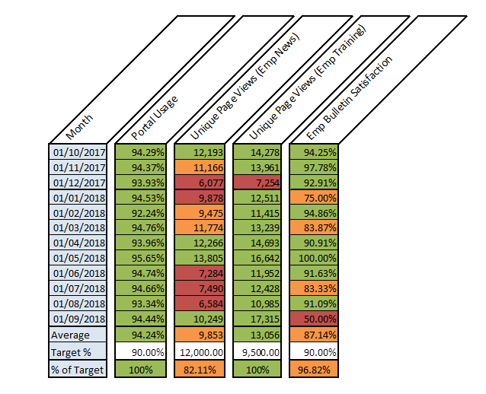

- OM11 results for contract year 8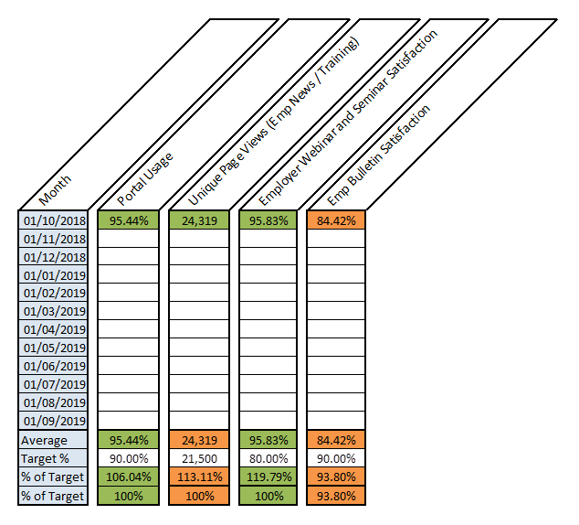
- OM14 (MPO registrations) results for contract year 7: 1st October 2017 to 30th September 2018

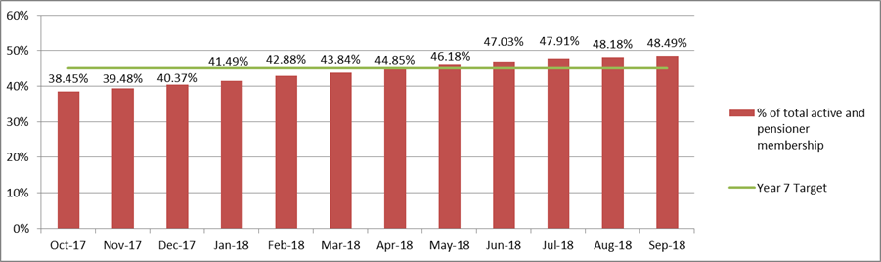

- Outcome Measure 14 targets are based on a % of Active and Pensioner members registered on MPO for each contract year. The targets for each contract year are:
- Contract Year 6 7 8 9 10
- Percent 35 45 52 59 62

Teachers’ Pensions contract centre

- TP has implemented a new resource scheduling model which deploys more staff at the beginning of the week (particularly Monday) to accommodate increased member contact. This has worked extremely well leading to quicker response times on Mondays.

- The current position is that contact centre performance remains stable. In August, queue time (Darlington) was 11 seconds. In September, queue time (Darlington) was 15 seconds, and in October, queue time (Darlington) was 12 seconds.

- The call Average Handling Time averaged 6.2 minutes, attributed to the complexity of the scheme and member enquiries related to this, however, Outcome Measures performance confirms that member experience is good with high satisfaction levels.

- The performance measures are set out in the table below (with data for the last quarter) SD6/260918 refers.

 | May  18 | June  18 | July  18 | Aug  18 | Sept  18 | Oct  18
Calls Answered | 34308 | 32249 | 31520 | 31938 | 27744 | 31916
Calls answered % | 97.4% | 98.3% | 97.2% | 97.5% | 96.3% | 96.3%
Average handling time  (seconds) | 363 | 360 | 360 | 373 | 374 | 371
Average queue time  (seconds) | 36 | 22 | 11 | 11 | 15 | 12
Average speed of answer  (seconds) | 37 | 23 | 31 | 31 | 43 | 40
Telephony complaints | 16 | 23 | 10 | 15 | 21 | 24
Outcome 6  Satisfied | 72.27% | 2.80% | 70.45% | 72.65% | 76.77% | 76.07%

31. The table below details the telephony performance metrics over the last 12 months.

- Performance Metrics for last 12 months

 | Nov  17 | Dec  17 | Jan  18 | Feb  18 | March 18 | April  18 | May  18 | June 18 | July  18 | Aug  18 | Sept 18 | Oct  18
Calls Answered | 28412 | 25068 | 39592 | 30960 | 30390 | 35702 | 34308 | 32249 | 31520 | 31938 | 27744 | 31916
Calls answered % | 72.3% | 96.2% | 93.8% | 96.2% | 96.3% | 95.7% | 97.4% | 98.3% | 97.2% | 97.5% | 96.3% | 96.3%
Average Handling time | 367 | 302 | 352 | 367 | 369 | 372 | 363 | 360 | 360 | 373 | 374 | 371
Average Queue time | 277 | 25 | 108 | 39 | 24 | 27 | 36 | 22 | 11 | 11 | 15 | 12
Average Speed of Answer | 69 | 37 | 94 | 45 | 43 | 49 | 37 | 23 | 31 | 31 | 43 | 40
Telephony complaints | 47 | 14 | 12 | 13 | 10 | 9 | 16 | 23 | 10 | 15 | 21 | 24
Outcome 5  Satisfied | 69.92% | 80.27% | 78.69% | 73.74% | 74.80% | 71.61% | 72.27%% | 72.80% | 70.45% | 72.65% | 76.77% | 76.07%

Customer satisfaction

- Negative feedback in the period centred on two main areas: employers (the level and accuracy of information given to members by their employer); and the website - difficulty with navigation and finding information remain regular trends. Improvements to the overall navigation of the website is underway, with continuous improvement applied following member feedback.

- TP record all complaints and assess whether the complaint is about the administration of the Scheme or some other aspect (such as regulations). The quarter trend is 43% of complaints are upheld and 57% are not upheld.

- In August, TP received 355 complaints, in September 304 and in October 323. In October, the highest complaint categories were about:
- Employer performance – 63 (19%)
- Website – 42 (13%); and
- Correspondence – 41 (13%)

- Of the 63 October complaints that were employer related, the three main drivers remain as opting-out; auto enrolment; and missing service. Correspondence complaints were due to delays in response or action.

- Two discussion groups were held in September covering subjects including MPO, social media and planning for retirement, with one group of eight Scheme members and a group of nine employers administering the Teachers’ Pension Scheme in schools and colleges.

- The main findings from the employer group were:
- Employers agreed that the portal was user friendly and had improved with the introduction of Monthly Data Collection (MDC).
- Participants who had telephone contact with Teachers’ Pensions spoke positively about the experience. They believed that Teachers’ Pensions was more approachable than it was a few years ago and better able to resolve queries on the phone.
- Employers trust Teachers’ Pensions to keep accurate records and maintain data securely. They feel that members need to be encouraged to take more responsibility for checking the accuracy of the data held by Teachers’ Pensions. Some expressed concern that the audit process was not sufficiently rigorous.
- In terms of the design of the Employer Bulletin, employers prefer a more functional presentation and do not necessarily think that images are necessary. They did, however, like the uniform and regular presentation of the new design and the dark text on white background.

- The main findings from the member group were:
- Members reported no problems with viewing MPO, the website, or emails on a mobile phone or tablet. However, only two members recalled having used mobile devices to access Teachers’ Pensions digital services.
- They felt it was important to retain the option to contact Teachers’ Pensions by telephone and requested earlier and later opening hours on some days of the week.
- Of the two retirement awards design options members were shown, the tabular format was preferred. On balance, most liked the simplicity and clarity of the table. Although the value of the annotated version was recognised – one member maintained that having all the information on one page was preferable – most participants thought that the annotated document was too complex.

- Member and employer views on training were quite similar:
- Both audiences are happy with a mix of online (recorded webinar) and face-to-face training, particularly if it is led by Teachers’ Pensions staff. Employers were also happy to deliver training to their staff if they were supported with good-quality materials from Teachers’ Pensions.
- Teachers’ Pensions could utilise the structures of multi-academy trusts and teaching alliances to gather large numbers of members together in one place and to target the training at groups of members at different life or career stages. Teachers’ Pensions might consider input about the Scheme for trainee teachers but should certainly develop packages for newly qualified and early career teachers to introduce them to the basics.
- The main focus for members is on the affordability of retiring before state pension age and the impact of doing so on their Teachers’ Pension Scheme benefits. They also want some basic facts about their contributions and how the scheme works.
- Employers felt that the training on offer on the Teachers’ Pensions website covered their main needs. Any further training they needed would focus on major changes to the Scheme or to the administration process.

- Future topics will include Contact Us, employer portal, employer training and Monthly Contribution Reconciliation (MCR).

The Pensions Regulator Engagement

- The table below demonstrates the establishments reported to TPR for non-compliance, detailed by sector:

Month | Independent | FE College | Academy
August | 1 | 1 | 7
September | 3 | 1 | 3
October | 2 | 0 | 3

- One Independent establishment was reported to TPR in August, September and October as having 8 months of contributions outstanding. This establishment was de-accepted from the scheme on 30/04/17.

- TP has continued monthly reminder actions, correspondence has been issued regularly and all cases escalated to the Finance Operations Team Leader. The DfE is aware of all cases and is assisting in continuing to pursue cases where appropriate and, where not, consider the case for write-off in line with HM Treasury guidelines.

Service Improvements

Valuation

- Initial results of the valuation have now been published based on assumptions and methodology in draft Directions provided by Her Majesty’s Treasury (HM Treasury). These results indicate that:

- the employer contribution rate is likely to increase significantly, from 16.4% of pay to around 23.6% of pay with effect from 1 September 2019; and
- the cost cap mechanism has been triggered (value of member benefits has fallen below the floor), meaning member benefits need to improve from 1 April 2019.

- In line with Regulations, the Scheme Advisory Board (SAB) has been asked to recommend member benefit changes to bring the value of benefits back in line with the cost cap. SAB has six months to report back on a recommended set of changes or if it has not been possible to reach agreement. It is for the department to then consider SAB’s recommendation or to choose to implement the default option, which is a change to the accrual rate.

- Due to the potential scale of the changes, the scope of the project is considerable. In order to successfully deliver the changes required as part of the valuation, a Project Manager (PM) and Business Analyst (BA) are required to provide the necessary support to ensure timely analysis, production of documentation, production of management information and office support is given.

- A Change Request has been agreed with DfE for these resources. They will be key in further developing the project implementation plan and high level engagement approach. These will be shared with IM&C sub committee.

RMH Replacement

- TP held a go/no go meeting in November and concluded that it was a no go for the scheduled move at the end of November.

- TP identified an additional issue to resolve with the web application and firewall. The IT health check has recently been concluded with no issues reported, but this necessary work has delayed the planned move to the Cloud.

- TP is confident that the steps required to migrate will be completed by mid-December, however due to the annual planned freeze on IT changes from the middle of December, migration will be scheduled for the New Year. TP and DfE are working on the revised implementation plan and are confident RMH is sufficiently robust for the extended period.

Monthly Contributions Reconciliation

- The next stage of Monthly Contributions Reconciliation (MCR) development is to make further significant improvements by moving to a position where TP can utilise monthly data provided by employers to reconcile with the contributions submitted by employers. Ultimately this will enable much more effective reconciliation, and provide much more certainty down to individual member level.

- This development places particular emphasis on the amendments and enhancements to:-
- A one-off Contributions Reconciliation Activity (CRA) to identify the current position/landscape in relation to MDC submissions versus corresponding monthly contribution breakdown forms.
- Attempting to identify reasons for variances and working alongside those employers to rectify issues prior to the implementation of Monthly Contributions Reconciliation (MCR). The purpose of this task is to simply check the amount of contributions on the current MDC submissions with the actual contributions paid. This will provide the platform for building the MCR solution.
- The existing MDC solution to automatically reconcile contribution information and record this data within HartLink.
- The introduction of an optional (preferred) Direct Debit Scheme process to enable TP to automatically deduct contributions from an employer following receipt of a fully compliant MCR submission.

- The above critical success factors will be benchmarked as part of project initiation and then, post go-live, tracked to understand the level of benefit achieved. The specifics of benefit realisation will be described in the benefit realisation strategy which will be defined as part of project initiation. These success factors will be reviewed and adapted depending on the employer/member landscape changes.

- In addition, TP is conscious that one of the key elements of this implementation is the usability and quality of the solution delivered. With this in mind, TP will work closely with employers and stakeholders to ensure the solution provides a consistent experience for all users. Further workshops are planned for January 2019.

- A high level communications plan is in development and will be shared with the IM&C sub committee.

Guaranteed Minimum Pension Reconciliation

- The reconciliation project is progressing well, second investigations continue and around 60k cases have been identified as being suitable for HMRC's new automated solution which was run in mid-September. The remaining cases are being investigated and second queries raised by TP have been fed back to HMRC.

- The project is due to end on 31st December 2018, before the rectification project commences from January 2019.

Guaranteed Minimum Pension Rectification

- The GMP communications letter will be issued to members from the second week in January 2019. This has already been discussed at the IM&C sub committee and the final version is in annex 1.

- It is expected that issuance of the letters will take place between January and the end of March, however, the project will run beyond this date as there is likely to be follow up correspondence with some of the affected members. TP is issuing letters to members using a phased approach (i.e. so many each week as calculations for them are finalised), so as to ensure there is capacity to support affected members appropriately without, for example, overloading the Contact Centre.

- Discussions have taken place around the best way to ensure this and it is proposed that GMP calls are diverted to other Capita Contact Centres, where staff already have experience of dealing with GMP related issues. The TP Contact Centre IVR will be updated to signpost callers, and calls will be diverted through a specific GMP helpline.

- The engagement strategy covering all this will be shared with the Information to Members & Communications subcommittee.

- The following chart shows the estimated overpayment impact for the 23k pensioner members who are affected by GMP rectification. These are members where it is clear that there is a need to amend the GMP information originally hat provided by HMRC. These volumes are based on analysis of a data set received from HMRC in June 2018 and the investigative work that has been completed since then. A further analysis is underway on a later set of data to confirm the final position but it is not expected to be significantly different.

Webchat
- The webchat trial commenced on 30 October and the initial feedback has been excellent from both TP staff manning the service and members. We will provide a full update on the trial in the next quarter’s report.

Data Strategy

- This aims to ensure that the TPS continues to have high quality data and remains one of the most innovative and successful public sector schemes. The data strategy encompasses a number of activities, aimed at ensuring we adapt to the changes occurring both within the scheme/pensions environment and externally.

- The latest developments, include provision of a monthly checklist to all employers utilising MDC by the 14th of each calendar month, covering a list of members who an employer has failed to cover on the previous month’s MDC file. This caters for scenarios where the member may have left the employer (but a withdrawal indicator was not provided) or where a genuine gap in service exists. MI reporting tools are available for TP to identify employers who are not following the checklist process.

- As TP performs the reconciliation on a monthly basis, this provides the opportunity to perform continuous risk based assurance i.e. review the way in which the employer administrates the Scheme monthly. This subsequently offers a further opportunity to simplify the existing End of Year Certificate (EOYC) audit process.

- This development will provide an additional level of assurance to the National Audit Office (NAO) as part of their annual audit prior to annual report and accounts sign-off. This assurance is three-fold: provides a greater level of detail; the ability to directly correlate contributions to service/salary; and more current data than the EOYC provides. Plans are that MCR will launch from January 2019 with employers being on-boarded from April 2020.

- Employers will receive a risk rating calculated by comparing MCR submissions and payment details against a set of criteria. Depending on the rating, employers will then be provided with relevant support to improve their data submissions and general data quality.

- An updated Data Strategy for contract Year 8 onwards has been drafted. This details TP’s strategy for ensuring the TPS remains one of the most successful and innovative schemes. It documents the scope of the strategy, focusing on sources of data and opportunities to progress a more modernised approach, and defines key responsibilities.

MPO adoption

- The table below details member volumes and MPO make-up based on the establishments:

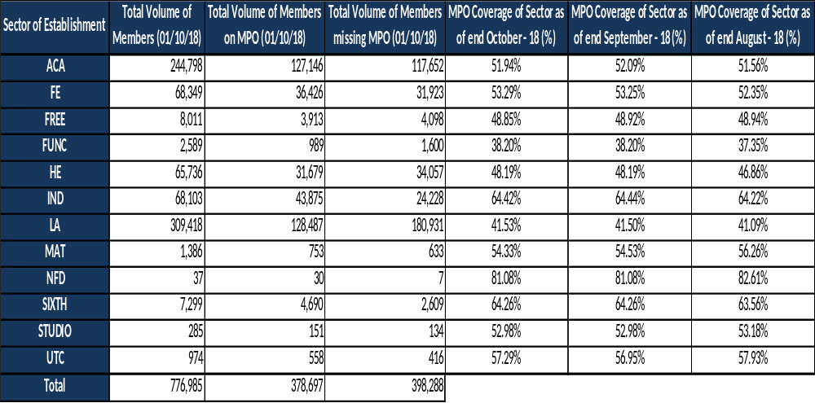

- There are now 811,344 members with an MPO account, of which, 345,256 are Active members.

Social Media

The scheme has 4,670 Twitter followers and 101,000 impressions, 8,909 Facebook ‘friends’ and 127,770 impressions, and 597 LinkedIn followers and 3,239 impressions, 275,744 You Tube views and 280 subscribers.

TP launched an Instagram page in October and to date, there are 227 followers and 127 likes. There has been an increase in social media engagement as members contact TP through Facebook and Twitter with their queries.

Engagement preferences

- The following graph (aggregated to the 3 month period) demonstrates the contact centre vs webform transactions by subject.

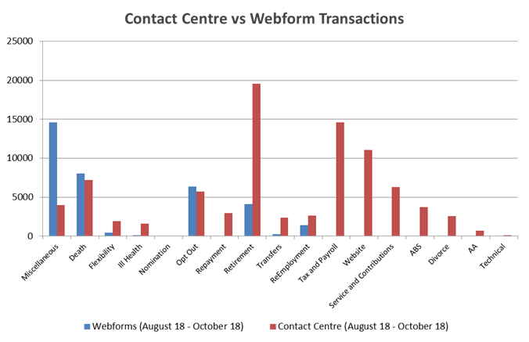

TPS Cash Forecasting Position

- August reported an over achievement on income of £12.46million (m) or 2.36% following July’s under achievement of £3.6m. £539.7m was received against the estimate of £527.2m. As a result, the financial year to date position reported an under achievement of £2.97m (0.11%) with £2,651m received versus the £2,654m expected.

- August expenditure reported a variance of £2.86m, or 0.34%, with £848m paid out against the forecasted £851m. This resulted in a year to date variance of 1.11% with £44.7m less paid out than anticipated (£3,972m v £4,017m).

- The monthly forecast fell outside the tolerance parameters set by HM Treasury for the first time, due to the last day of the month, when £36m of income was received against the forecasted £20m. TP took the correct action in refunding the full amount to DfE as is standard practice.

- September reported an under achievement on income of £32.7m or 6.08% following August’s over achievement of £12.5m. £505.2m was received against the estimate of £537.9m.

- The in-month activity featured an over achievement of £48.7m over the quarter followed by an under achievement of £76.5m over the quarter. As a result, the financial year to date position reported an under achievement of £20.5m (0.65%) with £3,157m received versus the £3,177m expected.

- September expenditure reported a variance of £4.67m, or 0.4%, with £1,172m paid out against the forecasted £1,177m. This resulted in a year to date variance of 0.29% with £14.8m less paid out than anticipated (£5,144m v £5,159m).

- October reported an under achievement on income of £6m or 1.16% following Septembers over achievement of £12.46m. £529.8m was received against the estimate of £523.7m. As a result, the financial year to date position reported an under achievement of £6m (0.65%) with £3,686m received versus the £3,680m expected.

- October expenditure reported a variance of £6.3m, or 0.77%, with £818m paid out against the forecasted £824m. This resulted in a year to date variance of 0.11% with £6.3m less paid out than anticipated (£5,962m v £5,968m).

- The net cash requirement position at October reported an underspend of £194m (main estimate versus actual) whilst the equivalent resource position showed an overspend of £16m.

TPS Accounts and Forecasting

- The Forecast Evaluation Report (FER) commission 2018 return was submitted on time, (outlining the root causes of any material differences in the forecast return for 2017-18 against the actual outturn).

- The autumn OBR forecast was delivered on time as per the timetable, the challenge session was attended by TP and DfE with answers to the queries raised submitted. The forecast was updated once September actuals were available and was resubmitted in October.

End of Year Certificates (EOYC) 2015-16 & 2016-17

- Four of the five returns in respect of 2015-16 remain outstanding (one academy and three independents). TPR has now written to these employers to understand their reasons for non-submission.

- In the quarter, there were six further returns received during October in respect of the 2016-17 exercise – 16 remain outstanding. This equates to 7,646 returns received of the 7,662 issued (99.8%).

- The 16 consist of two academies; 10 independents; two free schools; one studio school; and one multi academy trust (MAT). All 16 were again reported to TPR this month. Further chase up action will be taken during November.

- Over 7,000 audited returns in respect of 2017-18 have been received (non-LA and LA). The first reminder will be issued in November.

Unallocated Contributions

- The account balance over the quarter fell significantly over the quarter by over £16m, from £62m to £46m, and the volume of items decreased by 346 from 2,672 to 2,326. Work remains ongoing to maintain the position within the expected 1% tolerance target (against annual contributions).

- The breakdown by sector shows the majority is attributable to the following areas - £18.8m to Local Authorities (down from the £27.8m previously reported) and £13.6m to Academies (down from £15.4m).

- The balance of 2016-17 is such that TP will now be seeking agreement for clear down from the DfE Accounts team.

- DfE continue to monitor, support and challenge TP on the ongoing position at the monthly finance meetings and senior management KITs.

Debt – Overpayments

- The overpayment balance at the end of October reduced by £260k from £13.050m to £12.790m. The volume of outstanding cases also decreased from 2,983 to 2,795 (188 cases). The balance outstanding includes £6.955m in recovery equating to 54%, excluding death cases this percentage increases to 63%. In volume terms, 39% of cases are in recovery, rising to 68% when excluding death cases. There were receipts from 1,097 debtors this month (up from 944), nine debts have a future offset in place and nine have a charge on property secured against them.

- New invoices raised totalled £1.085m with the 912 invoices returning a cost per case of £1,190. This compares to the monthly average across the latest quarter of £1.162m raised from an average 766 invoices per month, with an average unit cost of £1,516. The value of recoveries in October was £1.35m which is the highest in the last year.

- The majority of the total outstanding represents re-marriage at £4.95m (38%); re-employment of £1.87m; lump sums of £2.02m; and death cases of £1.33m. Of the £5.41m being actively chased, £1.66m relates to re-marriage; £1.14m to death; and £1.09m to lump sums.

Debt – Arrears of Contributions

- The arrears balance increased this month from £4.41m to £4.99m (£591k). There were 847 cases outstanding compared to 814 last month. Of which 485 represent employee arrears (plus compound interest - CI) and 362 relate to employer arrears (plus CI).

- At the end of October, the arrears balance increased from £4.81m to £5.01m (£198k). There were 906 cases outstanding compared to 838 last month. Of which 534 represent employee arrears (plus compound interest - CI) and 372 relate to employer arrears (plus CI). The outstanding balance includes £576k in recovery via plans.

- There were 30 debts worth £238k over three months old that were recovered in the quarter. Overall £435k of prior months’ debts were fully recovered, consisting of £40k of member debt and £395k of employer debt.

Contractor & DfE Costs

- The administrative levy (0.08% of employer contributions) has been in place from September 2015. For the period of this report, the amount collected from the levy totalled £4.7m.

- The figures below represent spend to date in the current financial year.

 | YTD Profile | YTD actual | Variance | Narrative
Capita | £,Redacted | £redacted | -£redacted | Base Charge has been less than profiled due to service credits. Some costs profiled have not been invoiced.
TPSPB | £redacted | £redacted | -£redacted | Fees, travel and expenses and pension specialist. Meeting expenses have been lower than profiled.
GAD | £redacted | £redacted | -£redacted | Invoices have been less than profiled. October’s invoice will not be received until November.
OH Assist | £redacted | £redacted | -£redacted | October’s invoice not due until November.
DfE | £redacted | £redacted | -£redacted | Pensions Team and Finance costs

Risk

- MCR risks are being managed via the project board and are reviewed monthly. Without the MCR development and implementation, there is significant risk that:
- TP will not be able to continue to satisfy good governance around the managing public money rules due to divergence between employers’ systems for submitting salary and service data and contributions
- TP will not be able to continue reconciling membership and contributions within the tolerances prescribed within the annual audit underpinning the annual scheme accounts
- TP data strategy will fall short of demonstrating continued progress on data quality and the ability to reduce revisions to benefit awards.

Scheme Valuation key risks (not exhaustive)

- Timeline – There are many issues to handle and conclude within a challenging period of time e.g. SAB to make recommendations to the DfE SoS, when to implement changes to the contribution tiers, etc. However, these will be mitigated by maintaining tight programme management arrangements and maintaining clear and open communication channels with all stakeholders. There are further safeguards, for example, the default option of changing the accrual rate applies if SAB are unable to agree a recommendation or the Secretary of State considers that other options are not appropriate.

- Employer and member understanding – There is a prevalent risk that both employers and members do not engage with or understand or accept the valuation implications. TP will commence early engagement supported by DfE and SAB, and involving the TPSPB. A communication and stakeholder strategy will be employed and kept under constant review, to make sure this is mitigated appropriately.

- SAB decisions make delivery overly complex – There is a risk that SAB come up with a recommendation that involves a range of benefit changes that make implementing, administrating and communicating them more difficult, adding to complexity and cost. DfE and TP are working with SAB to ensure that a suitable range of policy tests and considerations are applied including one that looks specifically at deliverability. The Secretary of State also has power to apply the default option of changing the accrual rate if he deems that appropriate.

- Delays in IT and system changes – If the time taken to implement changes to IT and other systems is prolonged that increases the number of cases that have to be handled manually or re-worked subsequently, increasing the risk of errors and complaints. This will be handled as a distinct strand of the overall programme and managed closely to ensure issues are dealt with appropriately and promptly. Work will be front loaded as far as is possible and sensible, with a close eye kept on developments from SAB discussions and work prioritised accordingly. The blueprint from recent scheme reforms adds to mitigation, helping understanding of what needs to be changed and where if a particular benefit is to be amended.

- Competing priorities – The completion of the GMP reconciliation and rectification projects, along with much of this work falling during the busy September retirement period, increases the risk of delays, problems or errors. Progress across the piece will be continuously monitored under the existing contract reporting arrangements and valuation work will be subject to specific programme management arrangements handled by a dedicated project manager. This will ensure competing priorities and resource issues are spotted early and managed.

- Regulations – Amendments will require public consultation and given parliamentary legislation pressures, there is a risk that amended TPS regulations may not be laid in the summer in time for a 1st September commencement. The mitigation is that the current regulations do allow for the implementation of changes to the employer contribution rate without further change and the benefit improvements plus change to contribution tiers can if necessary be implemented in anticipation of the changes being cemented in regulations.

General Risks

- TPSPB Chair, Neville McKay, has built links with the Audit and Risk Committee (ARC) and will be attending the ARC meeting scheduled for Wednesday 19th December as a guest. Nigel Johnson, ARC Chair, will be attending TPSPB on 23rd January 2019 as a guest.

- The risk management process remains robust, with regular monthly meetings held between the DfE Senior Risk and Finance Manager, DfE contract Manager and TP Risk Manager, to assess the level and status of active risks, to discuss potential emerging risks and approaches to continuously improve risk management.

- The Teachers’ Pension Scheme Risk Appetite has been reviewed and approved by the Quarterly Strategy Board (QSB). The Scheme Manager has overall ownership of the Appetite. Risks that require intervention will be escalated to QSB for review and action.

- There are 26 strategic risks under management (27 at last reporting period). Three of the risks have MEDIUM net risk scores and the remaining 23 are LOW. All have a number of existing controls in place and continue to be actively monitored and mitigated.

- In addition, there are a further 18 operational (service delivery) risks under management (21 at last reporting period). One risk is rated as HIGH. This risk relates to the significant increase in the volume of member engagements and transactions (including data amendments from employers). The remaining risks are rated MEDIUM (3) and LOW (14).

GIA

- The Capita Group Internal Audit (GIA) Plan continues to progress well with the table below confirming position against the plan.

Overdue 1-30 days: Green; 31-60 days: Amber; 60 days plus: Red
Source | Total Open |  |  |  | 0 to 30 days |  |  |  | 31 to 60 days |  |  |  | 60 days + |  |  |  | Trend
Source | C | H | M | L | C | H | M | L | C | H | M | L | C | H | M | L
TPS Operations | 0 | 0 | 1 | 0 | 0 | 0 | 0 | 0 | 0 | 0 | 0 | 0 | 0 | 0 | 0 | 0 | 

Progress against 2017/18 Assurance Pl

KEY: ¹GIA Report Rating: E=Effective; IR=Improvement Required; SIR=Significant Improvement Required; Business Assurance Rating (Aligned to Group Risk Framework): WT = Within Tolerance; AT = At Tolerance; U = Uncomfortable; C = Critical)
Review Title | Q1 | Q2 | Q3 | Q4 | Current Status | Target Final Draft ToR |  | Actual Final Draft ToR | Final ToR | Target Final Draft Report | Actual Final Draft Report | Final Report | E/IR/ SIR/I2 | C | H | M | L
Capita Group Internal Audit (GIA)
Payment Out Controls |  |  |  |  | Final Report |  | Jan 2018 | 24/01/18 | 31/01/18 | Mar 18 | 12/03/18 | 28/03/18 | E | - | - | 1 | 4
Business Continuity / Disaster Recovery |  |  |  |  | Final Report |  | Mar 2018 | 20/03/18 | 28/03/18 | Jun 18 | 30/07/18 | 17/08/18 | IR | - | - | 4 | -
RMH Environment |  |  |  |  | Deferred |  | Review ‘Deferred’ into 2019 Plan to review encompass new environment and replaced with DfE requested review of Exit Transition Plan (Q4, 2018)
Member Experience (Contact Centre) |  |  |  |  | Fieldwork |  | Oct 2018 | 31/10/18 | 05/11/18 | Jan 19
Exit Transition Plan |  |  |  |  | Fieldwork |  | Sep 2018 | 06/09/18 | 05/10/18 | Dec 18
GDPR |  |  |  |  | Planning |  | Nov 2018
GIA Annual Assurance Statement (2017 / 2018) |  |  |  |  | Final |  | N/A | N/A | N/A | N/A | N/A | N/A | N/A | - | - | - | -
CES Head of Business Assurance Activity (HoBA)
CES AAF 01/06 (KPMG) |  |  |  |  | Final Report | N/A |  | N/A | N/A | N/A | N/A | 30/04/18 | N/A | - | - | - | -
Contract Outcomes |  |  |  |  | Final Report | Sep 2017 |  | 28/09/17 | 09/10/17 | Nov 17 | 17/01/18 | 07/02/18 | AT | - | - | 5 | 2
2nd Bite PI Remediation |  |  |  |  | Final Report | Mar 2017 |  | 05/04/17 | 09/05/17 | Jun 17 | 03/04/18 | 30/04/18 | WT | - | - | - | -
Quality Reporting |  |  |  |  | Draft Report | June 2018 |  | 06/06/18 | 13/06/18 | Jul 18
Exception Report Management |  |  |  |  | Planning | Nov 2018
Factor Change Management |  |  |  |  | Planning | Nov 2018

Acronyms used within this report:

AA | Annual Allowance | ARC | Audit and Risk Committee
BA | Business Analyst | BAU | Business as Usual
CCN | Contract Change Notice | CETV | Cash Equivalent Transfer Value
CRA | Contract Reconciliation Activity | EOYC | End of Year Certificate
FER | Forecast Evaluation Report | GAD | Government Actuary’s Department
GDPR | General Data Protection Regulations | GIA | Group Internal Audit
GMP | Guaranteed Minimum Pension | HMRC | Her Majesty’s Revenue and Customs
MCR | Monthly Contribution Reconciliation | MDC | Monthly Data Collection
MPO | My Pension Online | NAO | National Audit Office
OBR | Office of Budgetary Responsibility | PM | Project Manager
QSB | Quarterly Strategy Board | RMH | Restricted, Managed, Hosted (secure)
SAB | Scheme Advisory Board | SLA | Service Level Agreement
SoS | Secretary of State | TPR | The Pensions Regulator

Annex 1 GMP Rectification Letter
Changes to your Teacher’s pension
Recently Her Majesty’s Revenue and Customs (HMRC) and the Teachers’ Pension Scheme (along with other pension schemes) took part in an exercise to reconcile pension data. As part of this exercise we’ve identified that unfortunately your teacher’s pension has been overpaid.

The Department for Education (DfE) has agreed that, in this exceptional circumstance, you are not required to repay the overpayment.

The overpayment occurred due to changes in an element of a pension (which is included within your teacher’s pension), called Guaranteed Minimum Pension (GMP). This is the minimum pension any scheme must provide as a condition of being contracted out of the state additional pension scheme. Certain parts of the GMP are not increased by the Teachers’ Pension Scheme from the time you begin to receive your State Pension because the increase is included in your State Pension.

The reconciliation exercise has shown that HMRC need to amend your GMP and that means the information we held about the level of your GMP was incorrect. This also means that the annual increases applied to your teacher’s pension have therefore been too high.

The statutory arrangements governing the Teachers’ Pension Scheme mean that in order to prevent further overpayment, we need to correct your current level of teacher’s pension. From [insert date], your monthly pension amount will be [insert amount]. We must point out that there is no discretion that enables us to continue to pay the incorrect higher amount.

If you’ve any questions about this letter, please contact us securely via My Pension Online (MPO). MPO is an online secure portal that lets you check and manage your personal pension information. If you’re not already registered, visit our website today at www.teacherspensions.co.uk and select ‘Member registration’. Alternatively, you can call us on our dedicated number XXXX XXXXXXXX.

For further help you can contact The Pensions Advisory Service (TPAS). They are an independent organisation funded by the Department for Work and Pensions. It is staffed by pension professionals who can give impartial guidance on pension related questions or problems. Their service is free and confidential.

They can be contacted via;
- Helpline 0800 011 3797 9am to 5pm Monday to Friday, or
- Webchat available through their website 9am to 6.20pm Monday to Friday and 7pm till 9pm every Tuesday, or
- Online Enquiry available through their website

For more details about how they can help their website address is www.pensionsadvisoryservice.org.uk.

Yours sincerely, Xxxxxxxx [name] Xxxxxxxx[Job title]

